**Singular Space**

**Shannon Collis & Liz Donadio**

Institute of Contemporary Art, Baltimore

16 West North Ave

Baltimore, MD 21218

**Exhibition Dates:** January 5 – 26, 2019

**Opening Reception:** Saturday, January 5, 7-10pm

**Artist Talk:** Saturday,January 19, 4pm

An artist talk with special guests Eli Pousson and C. Ryan Patterson. Pousson is the Director of Preservation & Outreach at Baltimore Heritage and Patterson is a Public Art Administrator at the Baltimore Office of Promotion & the Arts.

**Open Hours:** Saturdays and Sundays 12-4pm, or by appointment

**Contact:** icabaltimore@gmail.com

By challenging perceptions of the built environment, *Singular Space* captures the essence and physicality of municipal art, viewed through an abstract lens and connected to the urban landscape. Collis and Donadio have created a multi-faceted portrait of Forum Fountain, a Brutalist-inspired public sculpture located behind Paul Laurence Dunbar High School in East Baltimore. The culminating installation expands the life of Forum Fountain and features immersive video projection and sound. Architecture can be an extension of the physical self: Buildings tell us about our bodies, both personal and social, and structure our experiences and behaviors. *Singular Space* serves as a multi-sensory palimpsest, reminding us that public space is mutable and cannot be erased- even in the face of continual destruction or neglect.

**Shannon Collis - shannoncollis.ca**

Shannon Collis is an interdisciplinary artist whose studio practice focuses on creating installations and interactive environments that explore various ways in which digital technologies can transform one's perception of audio and visual stimuli. Her work has been exhibited widely across North America as well as in Europe, Asia, Australia, and Brazil. Collis is a 2005 graduate of the Master of Fine Arts program at the University of Alberta, Edmonton, and has completed postgraduate research at Concordia University in Montreal in the area of digital media and computation arts. She is also a 2015/18 recipient of a Visual Artist Grant from the Canada Council for the Arts. Collis is currently an Associate Professor at the University of Maryland, where she teaches digital media and sound.

**Liz Donadio – lizdonadio.com**

Liz Donadio is a multimedia artist whose work is centered on the nexus of art, ecology, and architecture. Donadio received her MFA from Towson University in 2012 and has been exhibited and screened nationally. She was the summer 2018 Bresler Artist in Residence at VisArts in Rockville, MD where she worked on a site-specific environmental project. Donadio is a Lecturer of photography and art history at Towson University and runs Color Wheel Digital, a fine-art print studio in Baltimore.

As collaborators, we combine our backgrounds in photography, digital video, and sound installation to create works that explore public spaces in transition, uncovering details of their past and possible futures. Our installations conjure meditations on the essence of urban landmarks and monuments.

**ICA Baltimore - icabaltimore.org**

ICA Baltimore is a collaboration of volunteers working to stage contemporary art exhibitions in available spaces in Baltimore. *Singular Space* is the twenty-ninth exhibition by the ICA since 2011.

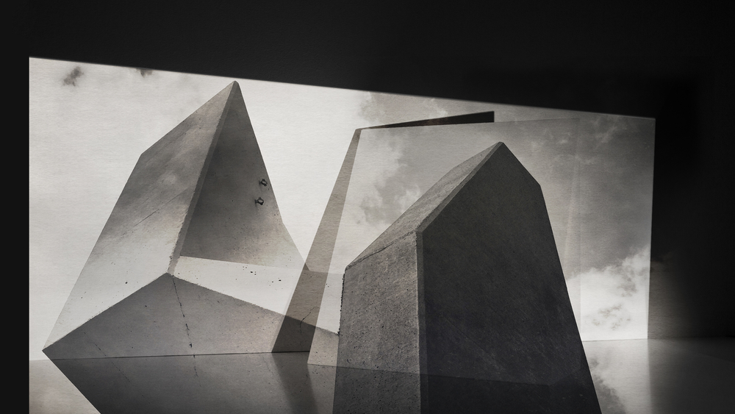

Image: Singular Space (installation detail)

Shannon Collis & Liz Donadio

Digital video projection

2018